**ABSTRACT**

**INTRODUCTION**

Skin cancer has been one of the top cancers in the world in the past few years. In England alone the number of skin cancer patients have raised to an alarming number of 303,135 recorded in the year 2016. This cancer is predominantly visible in Males more than females [1]. It is briefly divided into two Non- Melanoma and Melanoma. Melanoma or the Malignant Melanoma(MM) is a type of skin cancer that spreads to other organs. There are various types of Melanoma and it is a common type of cancer that is found at an early age under 50. In the UK alone there is a casualty rate of more than 2000 every year due to Melanoma[2]. If diagnosed in an early stage the chances of survival are as high as 99% in women and a little lesser in men[3]. Better diagnosis can be achieved with the aid of dermoscopy in contrast to the unaided eye by a significant amount of 10-30%[4].

Convoluted Neural Networks learn hierarchies of invariant features and classifiers from elucidate datasets. In this paper, we take forward the use of a Deep Learning, specifically Convolutional Neural Networks, to tackle the problem of lesion classification. This proposed network is trained from the archives of the ISIC challenge datasets[5].

**Background**

Melanoma is a type of malignant skin cancer which is caused to melanocytes cells. Melanocytes are those cells which secrete melanin which causes the tumour. According to the statistics from The American Cancer Society, in the United States alone in the year 2017 there were more than 87,000 new Melanoma cases being recorded and more than 9,300 causalities due to the same.

The main challenge is the visual diagnosis due to similarity of Melanoma skin lesions with the other benign skin lesions such as Seborrhoeic Keratosis and Nevus. Skin surface microscopy called ‘epiluminoscopy’ or ‘epiluminecent microscopy are used by expert dermatologists to review the lesion images. The main use of Dermascopy is to analyse and distinguish the malignant skin lesions such as melanoma and basal cell carcinoma from the benign lesions such as Seborrhoiec Keratosis and Nevus. In the widely used fluid immersion technique of imaging, mineral oil is applied over the lesion or in some cases alcohol is sprayed on to the lesion and a lens of high magnification strength such as 10x-14x is placed on top with contact to the skin.

Dermatologists have come up with various methods of classification of lesions as a melanoma with just feature recognition with the help of the eye.

The two most common ones are

1. 3-Point Checklist

In this method, a lesion is flagged Melanoma is two out of the three features are found in the lesion.

* Asymmetry
* Atypical Network
* Blue-white structures

1. ABCD Parameters

In this Melanoma screening method 4 parameters are used

* Asymmetrical Shape – Typically asymmetrical
* Borders-Irregular
* Color – Presence of more than one color.
* Diameter – If the lesion is larger than 6mm[6].

Computerized image diagnosis techniques have been developed and started to gain importance in the last few years. These techniques use digital image processing to classify skin lesions, that is malignant and benign skin lesions.



Figure 1: Examples of Skin Lesions from the ISIC 2017 Skin Lession Classification

Deep neural network models, specifically convolutional neural networks are the foremost in the field of image classification models for a numerous number of applications. This has made them one of the key players in the area of computer aided diagnosis using medical images. There have been many models recently published that has a very high accuracy rate of almost 95%. A key factor which contributed to the high performance is the availability of big dataset containing more than 100,000 images. In this project, we have used a similar convolutional neural network implementing the deep learning technique, but we have only access to a much smaller dataset.

**METHODS**

**Classification**

For classification we used transfer learning[7] technique where a pre-trained network can be used and modified to the target task. Transfer learning is used to achieve performance in the target task by gaining knowledge from the source task. Secondly it reduces the time required for a network to fully train from scratch[7].

Our first attempt was a network based on Inception V3[8] pre trained on ImageNet[9] using Tensorflow[10] using a linear stack model up to fully connected output layers giving n dimensional outputs. This method seemed to demand for effort and time given the fact that we are using transfer learning to be easier and quicker.

We then found tutorial[11] to carry out transfer learning with multi class images in Matlab[12] which makes the task of classification easier as a single one in contrast to, two binary classification.

We found out three factors limiting performance:

1. Amount of training data
2. Depth of the network
3. Computational power

.

We began collecting as much data as possible and was limited to computational power of our own devices which was a major bottleneck in the experiment. Given the limitation of data and the lack of computing power we had to use a higher programming language like Matlab[12] along with a well pre-trained and deep network like Alexnet[13].

**Training Data**

Thus, we collected training data from ISIC 2017 as well as 2018 web pages and acquired a total of over 1,300 Melanoma, 1,300 Nevus but only 250 Seborrhoeic Keratosis. The images were rotated in various angles to create additional datasets

To prepare the images for the network, each of the images were resized into the same dimensions of 227 by 227 as required by AlexNet. The images were first resized using padding. See Figure 2.

Padding is by including an extra feature that is black or white strip on both the side to change the dimension of an image. This was later changed because the network tends to learn the background padding of a class as a feature which is a negative for your network reducing its accuracy.

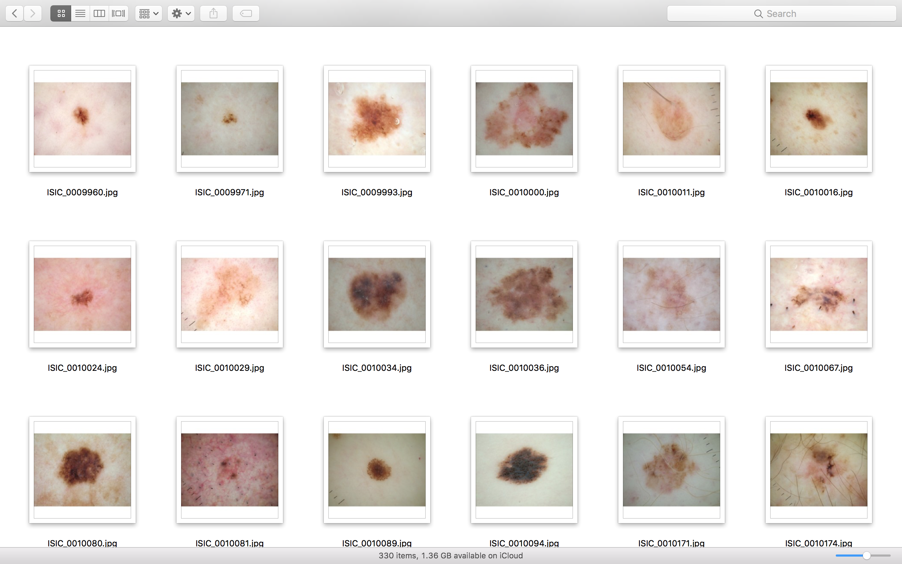

Figure 2 : Images resized using padding

A few background artifacts were found while analysing the training data. Many Nevus Images contained color gauze on both the sides, see Figure 3. Similarly there were bright light on both edges in Seborrhoeic Keratosis Images, see Figure 4. Each of these images were manually cropped in order to make sure that the network was learning the features of the images and not its background artifacts[14].

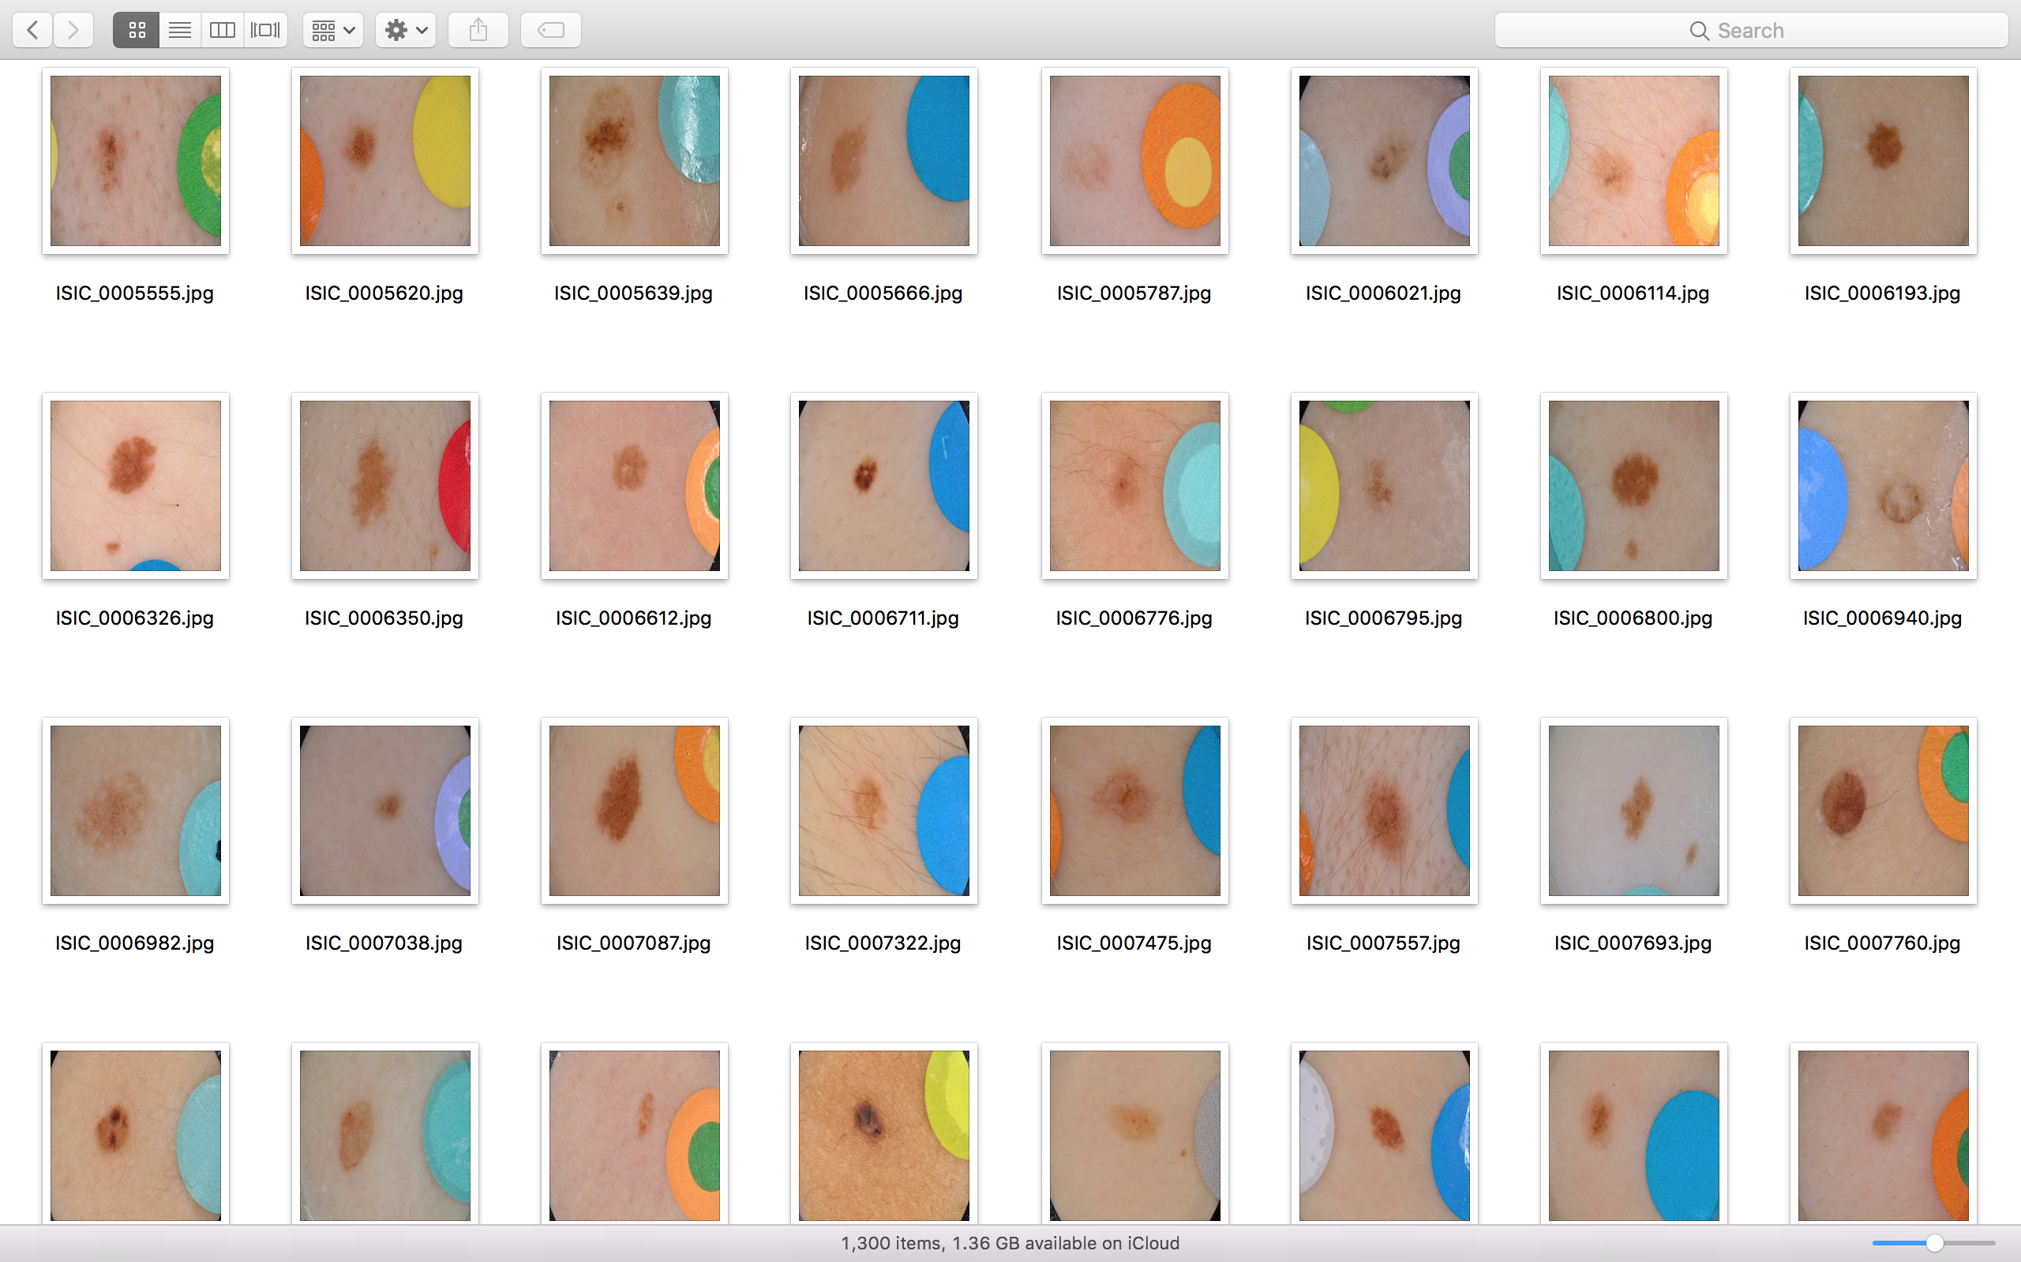

Figure 3:Nevus Images with color gauze

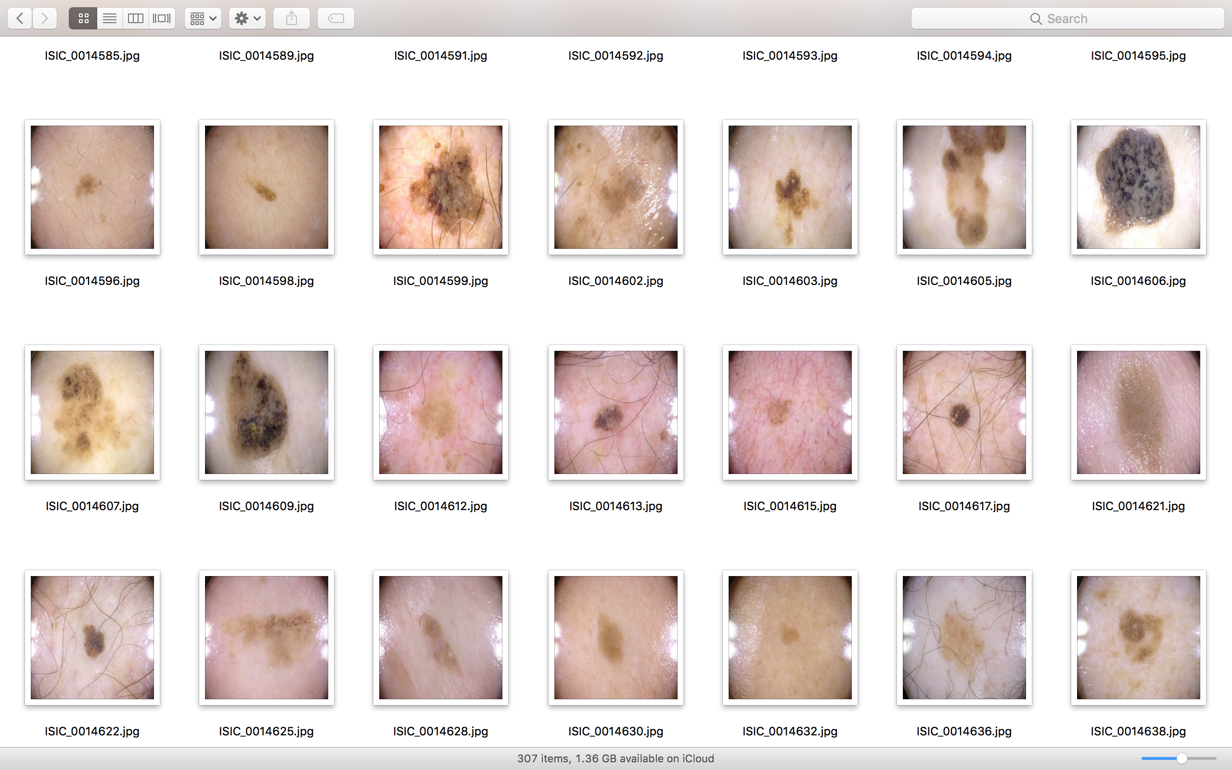

Figure 4 : Seborrhoeic Keratosis with bright light on the edges

**Model Architecture**

AlexNet is a deep convolutional network having 25 layers which is used to classify the images. The network operated with input image of the dimension 227 by 227[14]. AlexNet is a pre-trained network which has 1000 fully connected layers to classify the images. In its 23rd layer we modified the 1000 fully connected layers to 3 based on our requirement. In its 25th layer we made it a blank classification layer where the network learns from the training data provided.

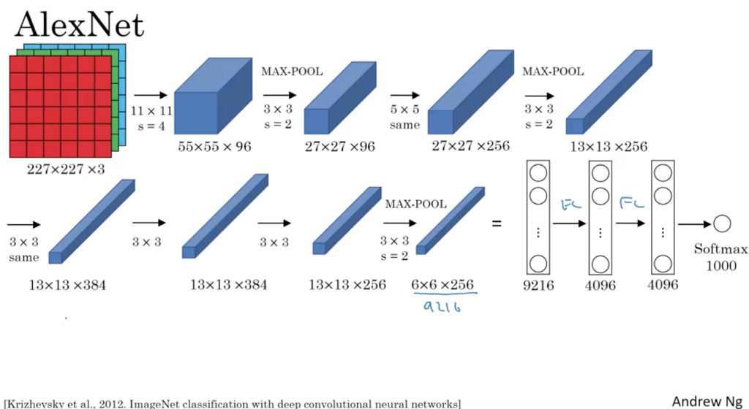

Figure 5: AlexNet architecture[15]

**Training**

The images were stored in an Image DataStore in Matlab from the root folder by including the subfolders and its names as well. This dataset was split into two Training data and Test data in the ratio 80:20 in a random manner and stored as separate image data stores. The images were trained using stochastic gradient descent with momentum (SGDM) optimizer, training options were then specified with learning rate to be 0.001 and the min batch size was maintained as 64[11]. The number of epochs were variable with a recommended number of at least 20. The network was then trained with the training image datastore over the layers with the specified options.

**Post Training**

The test images were taken and classified using the trained network to obtain the predicted labels. Then the accuracy was calculated by taking the mean of the predicted labels matching with the actual test labels.

**REFERENCES**

[1] Jasveer Kaur and John Broggio, “Cancer registration statistics, England: first release, 2016,” p. 2, 2018.

[2] “Skin cancer (melanoma) - NHS.UK,” 2017. [Online]. Available: https://www.nhs.uk/conditions/melanoma-skin-cancer/.

[3] O. of N. Statistics, “Cancer survival by stage at diagnosis for England ( experimental statistics ): Adults diagnosed 2012 , 2013 and 2014 and followed up to 2015,” *Off. Natl. Stat.*, pp. 1–23, 2016.

[4] A. Masood and A. A. Al-Jumaily, “Computer aided diagnostic support system for skin cancer: A review of techniques and algorithms,” *Int. J. Biomed. Imaging*, vol. 2013, 2013.

[5] C. N. Vasconcelos and B. N. Vasconcelos, “Convolutional Neural Network Committees for Melanoma Classification with Classical And Expert Knowledge Based Image Transforms Data Augmentation,” pp. 2012–2015, 2017.

[6] T. DeVries and D. Ramachandram, “Skin Lesion Classification Using Deep Multi-scale Convolutional Neural Networks,” 2017.

[7] L. Torrey and J. Shavlik, “Transfer Learning,” *Mach. Learn.*, pp. 1–22, 2009.

[8] C. Szegedy, V. Vanhoucke, S. Ioffe, J. Shlens, and Z. Wojna, “Rethinking the Inception Architecture for Computer Vision,” 2015.

[9] Jia Deng, Wei Dong, R. Socher, Li-Jia Li, Kai Li, and Li Fei-Fei, “ImageNet: A large-scale hierarchical image database,” *2009 IEEE Conf. Comput. Vis. Pattern Recognit.*, pp. 248–255, 2009.

[10] M. Abadi *et al.*, “TensorFlow: Large-Scale Machine Learning on Heterogeneous Distributed Systems,” 2016.

[11] “Deep Learning with MATLAB_ Transfer Learning in 10 Lines of MATLAB Code Video - MATLAB.” .

[12] Mathworks, “MATLAB - Mathworks - MATLAB & Simulink.” 2016.

[13] M. Z. Alom *et al.*, “The History Began from AlexNet: A Comprehensive Survey on Deep Learning Approaches,” 2018.

[14] Matt Berseth, “ISIC 2017: Skin Lesion Analysis Towards Melanoma Detection,” pp. 1–4, 2017.

[15] A. Krizhevsky, I. Sutskever, and G. E. Hinton, “ImageNet Classification with Deep Convolutional Neural Networks,” *Adv. Neural Inf. Process. Syst.*, pp. 1–9, 2012.